**Identifying Patterns And Trends In Campus Placement Data Using Machine Learning**

Team leader:P.Nisha

Team Member:M.Pavithra

Team Member:P.Pavithra

Team Member:M.Pradhiksha

**Introduction**

**1.Overview:**

**Project Description:**

Campus recruitment is a strategy for sourcing, engaging and hiring young talent for internship and entry-level positions

**Project Flow:**

* User interacts with the UI to enter the input.
* Entered input is analyzed by the model which is integrated.
* Once model analyzes the input the prediction is showcased on the UI

2.Problem Definition&Design&Thinking:

College Campuses are the pool of fresh and untapped talent. From future Managers to Entrepreneurs, you can find a variety of talented College campuses. For companies who are into Entry-level Recruitment, campuses Placements are no short of a blessing.

But wait, is it?

There are 1000s of colleges in India and lacs of students. So problems in hiring are obvious. This blog talks about all the possible problems that Recruiters face during Campus recruitment. Read it to better prepare for your next Campus Hiring schedule!

**1. Limited Staff**

Most of the Campus Recruitment drives have a fixed pattern. Companies visit colleges with a small team that does all the hiring. Now since the staff is outnumbered by the high number of applicants, it poses a lot of problems in managing the whole drive. Candidate engagement is a big challenge and sometimes few candidates miss to be properly notified by the company about the further process.

All this makes the process extremely slow, inefficient, and complicated.

**2. Lack of proper branding**

A healthy culture in any Company involves diversity and inclusivity, something which can only be possible by having Employees who can balance their work and be an effective contributor to the company at the same time. All this starts with hiring freshers because they are raw and can be trained from scratch.

But since Companies are on a time crunch, most of them aren't able to visit most colleges or even if they do so, they look to wrap up the drive fast which invites a lot of problems. Remember that how a Company conducts Campus Drives also contributes greatly to it's branding. An outdated Campus Hiring pattern can easily put your Company behind your competitors.

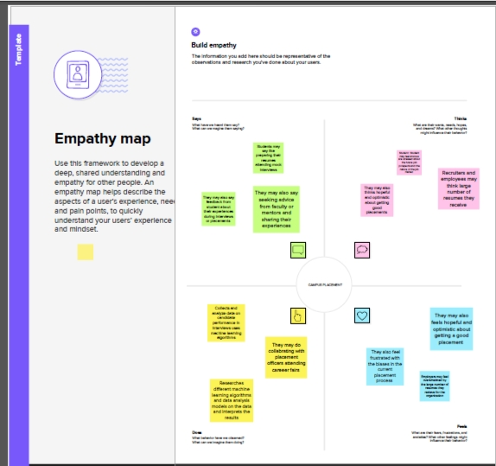

**3. High Candidates numbers**

Let's face it - in any Campus Drive, thousands of candidates will be screened. Usually, Companies visit campuses with 2-4 members. That means the staff is outnumbered while screening the candidates. Any Employee driven Company will not promote an excessive burden on any of its employee. Still, screening 1000s of candidates in a matter of 2-3 days is a big challenge. Moreover, the screening has to be done properly so that deserving candidates aren't left behind.

Establishing proper communication with thousands of candidates all at once is another demanding task to do.

**4. Negative Candidate experience**

As the hiring industry is candidate-driven, the first impression during Campus Drives does a majority of the work. Any candidate will prefer a company that uses modern tools in hiring than a company that uses traditional methods and a lot of time. Moreover, if a company isn't properly conducting the Campus drives, chances are they might miss out on quality talent.

**5. Importance of a Resume**

One important document that flips the game for any candidate is the Resume. In any Campus Drive, it is the go-to document - both for students as well as the Recruiters. Yes, things like an impressive Resume and where a student did their internship from matters a lot, a candidate is more complex than that. Companies often fail to look beyond the resume of a candidate and make hiring decisions, hence missing out on quality talent even after personally visiting the Campus.

They should have a system that emphasizes on the overall personality of the candidate and not just one document.

3.Result:   
 After the selection of the candidate, **the offer letter will be given**. The company executive tells about the guidelines related to joining process and about the company's policies

4.Adavantages and Disadvantages:

Campus placements **smoothen the overall process of getting that first job**. Without it, looking for a job as a fresher is like going into the wilderness unprepared. If you're a student from a reputable institution. You will benefit from the institution's reputation, which increases your marketability to employers

**Fresh candidates selected through campus placements require adequate training for work**. This is an additional expense for the company. Also, students can't work with their dream company and will have to remain satisfied with the company that recruits them during campus selection.

5.Application:

How do I write a letter to college for campus placement?

This is with regards to the subject line, we _____company name_____would be immensely interested in conducting a recruitment drive in your organization. Positions Open: There is a requirement for 7 candidates but the count can go to even 15 if we find the best and worthful candidates during the recruitment process

6.Conclusion:

To conclude your report, **let us know how you found your placement and what skills and knowledge you think you have gained**: Did you find your placement interesting and enjoyable? Do you think you would want to work for the company or a similar company in the future (and why)?

7.Future Scope:

**To provide recruitment to students**. To provide exposure to BE pursuing students. To have good relations with the recruiters. Managing Recruiters correspondence and feedback's.

8.Appendix:

Source code:

**The college invites the best companies and companies with official partnerships to come and interview students to gauge their potential as future employees**. Companies may use their form of the interview process.